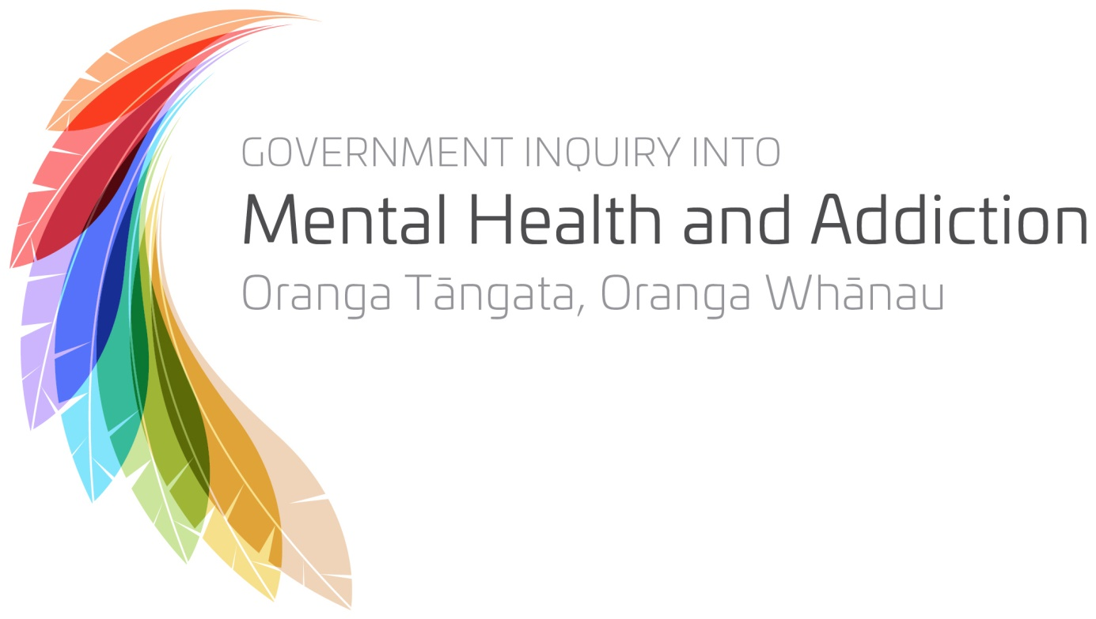

Public consultation on mental health and addiction in Aotearoa New Zealand now, and into the future

A chance to have your say

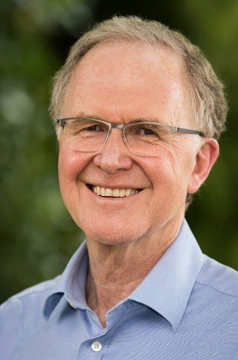
Introduction
Nau te rourou, naku te rourou, ka ora ai te Iwi
On 31 January 2018, the Government established an Inquiry into mental health and addiction. The ultimate goal is to improve the mental health and addiction outcomes of New Zealanders. We are a diverse and multicultural panel with a broad range of ethnicities, ages, backgrounds and perspectives.
Our task is wide ranging: we have been asked to look at how mental health is promoted and supported in New Zealand, and how interventions and services could be transformed to respond more effectively to the needs of people experiencing mental health and addiction challenges, including people affected by suicide.
We want to provide a clear direction for the future that generates hope and supports communities, whānau and family, providers and government to take action.
Providing a submission on this consultation document is one way you can contribute to this Inquiry. Our website has more information about other ways you can connect with us: www.mentalhealth.inqury.govt.nz.

Your views
There are five key questions that we would like to hear your views on. These questions are deliberately broad to ensure that they capture the full range of issues and solutions you may wish to share with us.
Your submission might be very specific, based on your own experiences of mental health or addiction. You might have insights as a service provider or a family member, supporting a person who has experienced mental health or addiction challenges. As well as your personal experiences, you might also have ideas about what improvements could be made across the whole country and the entire system.
Everyone’s views are important because they will help us to understand what people around the country think is working well and what needs to improve.

Tell us what you think
We want to hear what you think, especially what your solutions are to make things better. Your comments and ideas might be about anything you think is relevant, including the role of different sectors — such as education, disability support, social welfare, housing, justice, policing and prisons — and the impact of various risk factors, for example: housing issues, violence, unemployment, social deprivation and poverty.
To help you make your submission, you may want to read a simplified version of our Terms of Reference: www.mentalhealth.inquiry.govt.nz.
Overall, we want to hear your ideas about solutions that might help to:
- build positive mental wellbeing for all New Zealanders
- help people to deal with mental health challenges early (before specialist treatment is required)
- enable people to avoid becoming addicted to something that causes harm
- prevent people from taking their own lives
- make it easier and faster to identify when someone is facing mental health or addiction challenges and get them help more quickly
- improve the quality of the support and interventions given to those who need it, and
- any other ideas about how to improve mental health and wellbeing in Aotearoa.
Your views matter
Every submission is important and all will be read or listened to. When the Inquiry finishes, we will release a report that explains what people told us needs to change and how it should change.
How your information will be managed
The only people who will have access to your submission will be the Inquiry panel and nominated staff of the Inquiry. It is possible that some content from submissions, such as individual stories and experiences, may be referenced or included in the Inquiry report but identifying information (such as names) will be excluded, and stories and experiences will be kept anonymous where possible.
You can tell us that you would like your submission, or certain parts of it, to be kept confidential so that it won’t be used in the report. You can find out more about our management of your submissions during and after the Inquiry here: www.mentalhealth.inquiry.govt.nz
You can attach documents to your submission
You can also attach documents to your submission. If you are completing your response online, there is an opportunity to attach anything you want to contribute (except current service complaints which are outside the Terms of Reference). If you are completing a paper version of this document, please attach any additional information to your submission when you send it to us.

You can provide more detailed comments
You may wish to make more detailed comments about areas such as design and provision of services, how to improve coordination between the health sector and other areas, workforce planning, collection and sharing of information, and funding, governance and accountability. You can include these in your answers, or put them in a separate submission from you or your organisation.
Conclusion
This Inquiry is a once in a generation opportunity for change. We will be working hard in the time available to gather the best information we can, and your views are part of this.
Your voice is important and will help us set the direction for mental health and addiction in Aotearoa. Thank you in advance for taking the time to complete your submission — we look forward to receiving it.

Mahi Ngātahi he oranga mō tatou,

Professor Ron Paterson (Inquiry Chair)

- What’s currently working well?
We know there are concerns with how we view mental health and addictions, promote mental wellbeing, and provide support and services to those who need it. We also know there are some good things already happening that could be supported and expanded. We want to hear about the good things currently happening.
What do you think is currently working well? Why do you think it is working well? Who is it working well for?

- What isn’t working well at the moment?
We know that some things are not working so well at the moment. We want to hear what you think isn’t working well, and where there might be gaps or problems — such as the underlying causes of the problems, unmet needs, the way services and support are delivered, the links between services, and the availability of services and resources.
What mental health and addiction needs are not currently being met? Who isn’t receiving the support they need and why? What is not being done now that should be?

- What could be done better?
You’ve told us what you think is working well, and what isn’t working well. In this section we want to hear what you think would make the biggest difference to improve and transform mental health and addiction outcomes in New Zealand. This might include your ideas about how to prevent people from developing mental health or addiction problems, as well as ideas about how to improve the support and treatment given to those who need it.
Your ideas might be focused on specific communities or groups of people, or more general views about what could be done better. We want to hear all ideas — big or small, specific or broad, innovative and new, or building on something that is already happening.
What are your ideas about what could be done better or differently to improve mental health and wellbeing in New Zealand? What could be done better or differently to prevent addiction from occurring? What could be done better or differently to prevent people taking their own lives and support those affected by suicide?
How could support be better provided to those who need it?

- From your point of view, what sort of society would be best for the mental health of all our people?
We want to hear what your ideal, healthy New Zealand would look like. What would be the foundations, principles or values that would support positive mental wellbeing for all New Zealanders, and how we might best assist those who need help.
If you could refresh how the system in Aotearoa promotes positive mental wellbeing, and prevents, identifies and responds to mental health and addiction challenges, including suicide, what would that system look like, how would it be different from what we have today, where would you start, and where would you focus your efforts?

- Anything else you want to tell us
Is there anything else you want the Inquiry to know?

- Before you go…
  - About you
Before you finish, please tell us a few things about yourself. This information will help us better understand the information we receive, where the areas of unmet need are, and identify ideas that best fit various groups, because what works well for one group might not work for another.

Is this an individual submission, or a submission on behalf of a group or organisation?
Individual
Organisation
Please state which organisation:

Group
If your submission is on behalf of a group, how many people does it represent?

Please indicate which of the following best represents you. Tick as many as appropriate.
Personal experience of mental health and/or addiction challenges
Family, friend or whānau of someone with mental health and/or addiction challenges
Current/past engagement with mental health or addiction services
Family, friend or whānau of someone with experience of mental health or addiction services
Individual service provider or support worker
Advocate
Service provider organisation
  - please specify type of provider (eg, DHB, PHO, primary practice)

Representative or professional organisation
NGO
Researcher, Academic, Commentator
Central or Local Government agency
Interested member of the public
Other (please specify)

If you are a person who has accessed services either currently or in the past
Please indicate if you identify with any of the following groups. Tick as many as appropriate.
New Zealand European/Pākehā
Māori
Children
Youth
Pacific peoples
People with disabilities
Deaf
Older people
Immigrant and refugee groups
Veteran
LGBTIQA+
Prison populations
Non—custodial offender
Rural
Other (please specify)

If you are a provider, representative, or professional organisation
Please indicate if you provide services specific to any of the following groups. Tick as many as appropriate.
Māori
Children
Youth
Pacific peoples
People with disabilities
Deaf
Older people
Immigrant and refugee groups
Veterans
LGBTIQA+
Prison populations
Non—custodial offenders
Rural
Other (please specify)

Sex:
Female
Male
X (Gender diverse/Indeterminate/Intersex/Unspecified)
Prefer not to say

Age:
Under 16
16 — 24
25 — 44
45 — 64
65 — 84
85+
Prefer not to say
  - Are there any parts of your submission that you would like kept confidential?

Yes / no (If yes, please clearly indicate in your submission which parts you request be kept confidential (eg, by highlighting confidential sections), and reasons why this is important to you)

Please indicate how you would like the confidential parts to be treated.
The identified parts of my submission are not to be referenced at all in the Inquiry report
The identified parts of my submission can be anonymised and used in the Inquiry report and other Inquiry documentation — for example published as part of an analysis of submissions
The identified parts of my submission should be anonymised before being seen by the panel
For further information about requests for a submission to be kept confidential, please visit the Legal Information about Your Submission webpage at www.mentalhealth.inquiry.govt.nz
Unless confidentiality is expressly requested, all submissions and evidence may be made publicly available at the discretion of the Inquiry.

