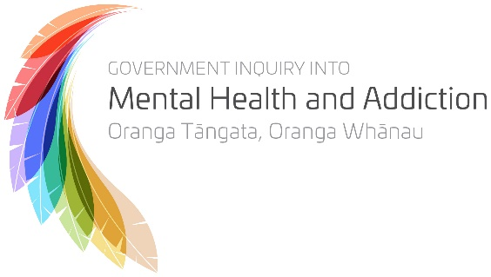

This is a survey to find out what people think about:
- Mental Health
- Addiction.
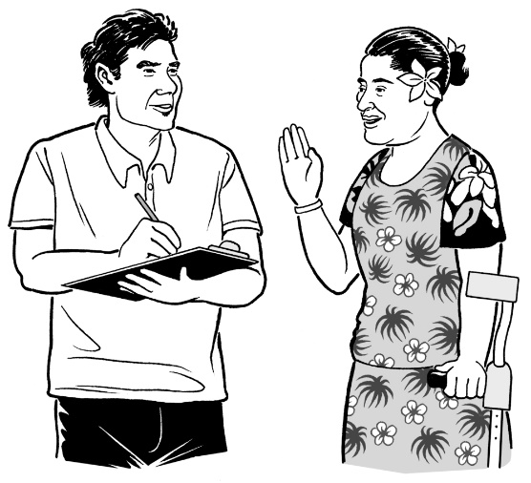
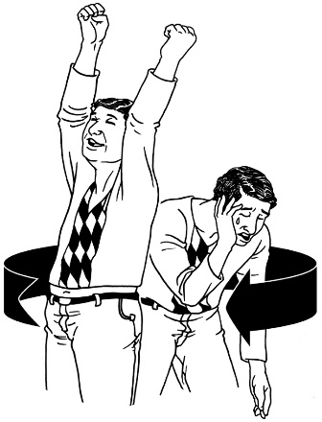

This is the Easy Read information and form to have your say.
Important information
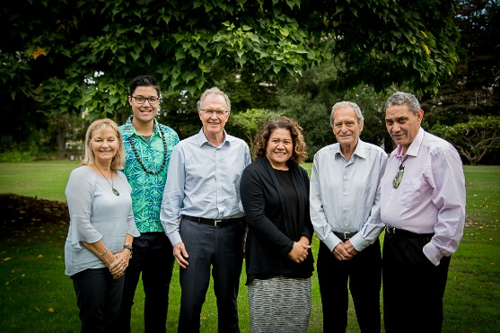
A group of people is trying to find out what other people think about:
- Mental Health
- Addiction.

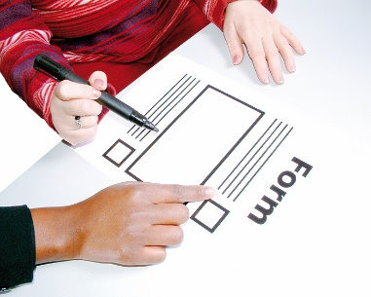
You can help the people doing this work by filling in this form.
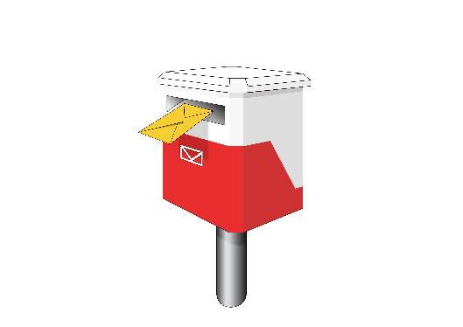

It would be best if you could send us your answers by 5 June 2018.

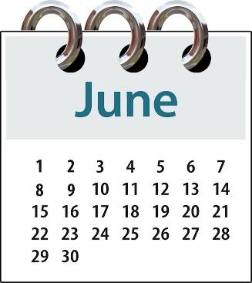
If you send us answers after 5 June we can still try to make them part of our report.

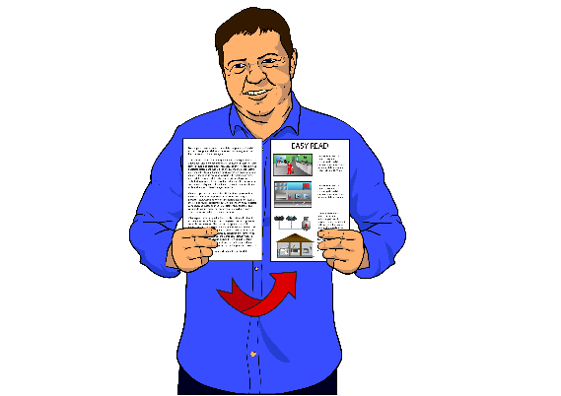
Is this booklet right for you?

We have made this information in a few different ways:

- Easy Read

- large font

This means big writing.

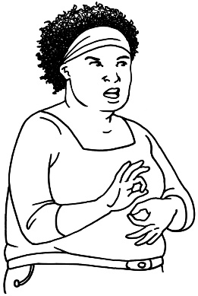
- New Zealand Sign Language with audio and captions.

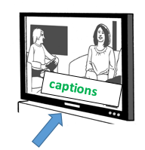
This means a video that shows:
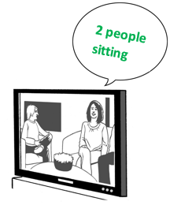
  - a person using sign language

  - words on the screen

  - a voice saying the words.

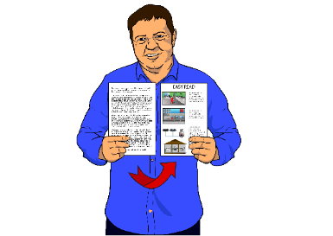
This booklet is the Easy Read version.

To get more copies of the Easy Read information go to this website:
https://www.mentalhealth.inquiry.govt.nz/consultation-document/have-your-say-easyread/

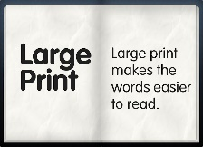
To get the information in large font go to this website:
https://www.mentalhealth.inquiry.govt.nz/consultation-document/have-your-say-large-text/
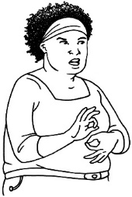

To see the New Zealand Sign Language video go to this website:
https://www.mentalhealth.inquiry.govt.nz/consultation-document/have-your-say-new-zealand-sign-language/

Before you start
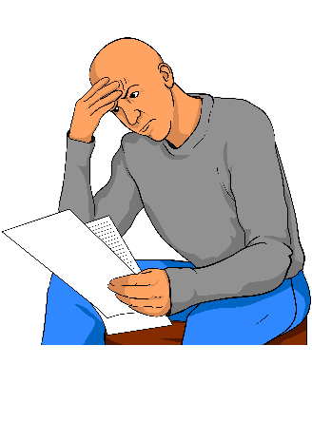

This is a long document.

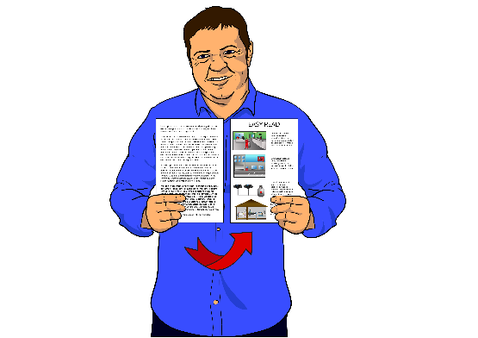
While it is written in Easy Read it can be hard for some people to read a document this long.

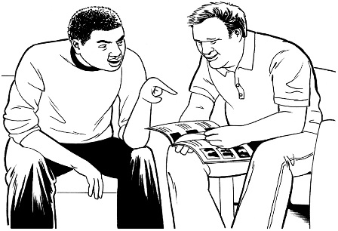
Some things you can do to make it easier are:
- read it a few pages at a time

- have someone help you to understand it.

Warning
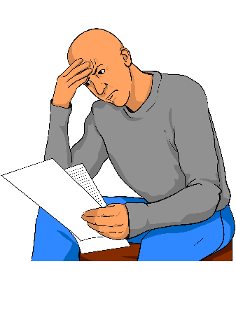
Some of the information in this document may make people upset when they are reading it.

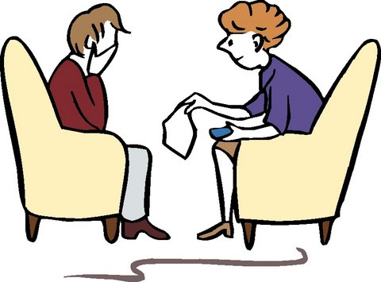
This information is:

- not meant to scare anyone
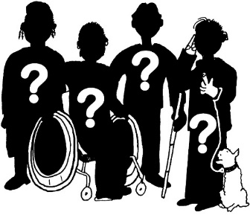
- not true for everyone.

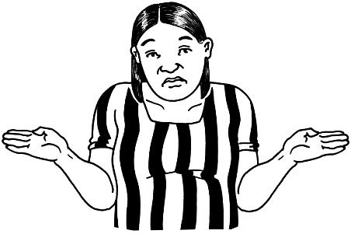
This information does not mean that these things will happen to you or someone you know.
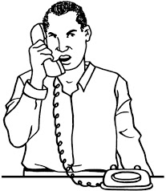
If you are worried after reading this document, talk about it with your:

- family
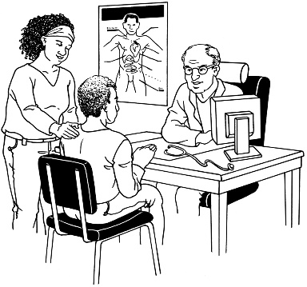
- friends

- doctor.

Words that are used in this book
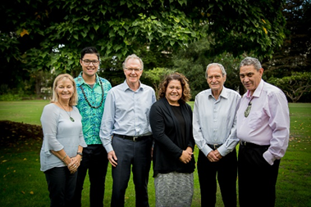
A group of people is trying to find out what other people think about:
- Mental Health
- Addiction.

In this book, Mental Health means having conditions like:
- Depression
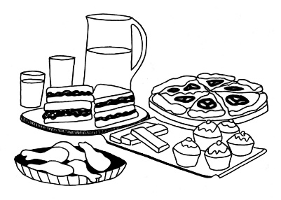
- Anxiety
- Bi-Polar disorder
- Schizophrenia
- Post traumatic stress disorder
- Eating disorders.

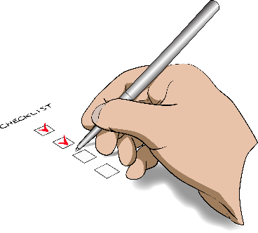
There are many other conditions.

These are just some of them.
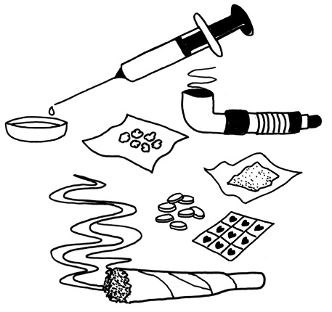
In this book, Addiction means not being able to stop yourself from using things like:

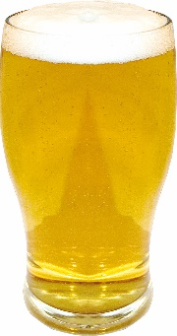
- drugs

- alcohol

- gambling money – like:
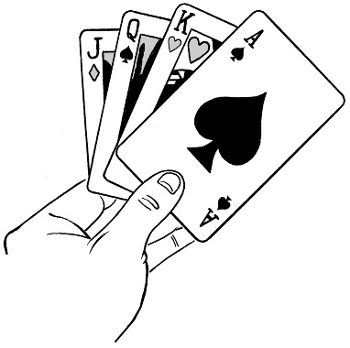
  - betting on the horse racing

  - going to a casino.

There are many other things that people can be addicted to.

These are just some of them.

A note from the Chairperson of this work
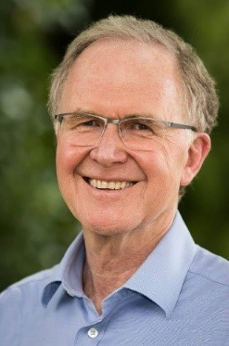

My name is Ron Paterson.

I am the Chairperson of the group who is doing to work to find out what people think about:
- Mental Health
- Addiction.

This work started on 31 January 2018.

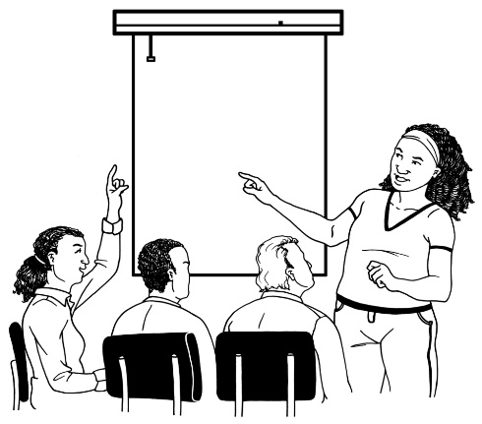
In this work we will be looking at:

- how we can better support people who have problems with
  - Mental Health
or
  - Addiction
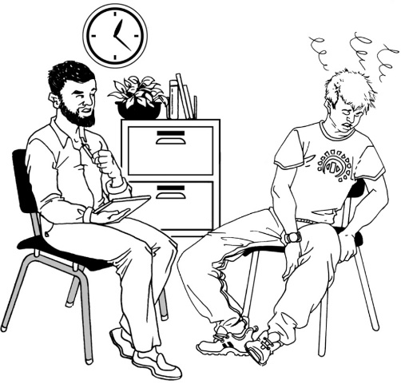
- how we can stop people from getting problems with:
  - Mental Health
or
  - Addiction.

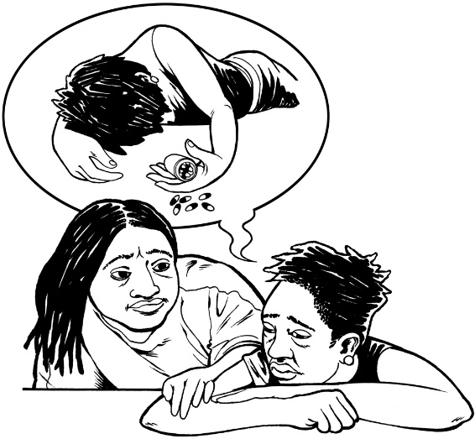
We also want to help people who feel so bad they do not want to live anymore.

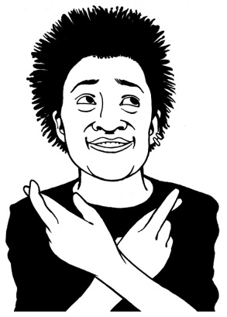
We want people to have:
- hope that things will get better

- better support in the future.

You can help us to do this work by filling in this form.

There are 5 sets of questions in this form.

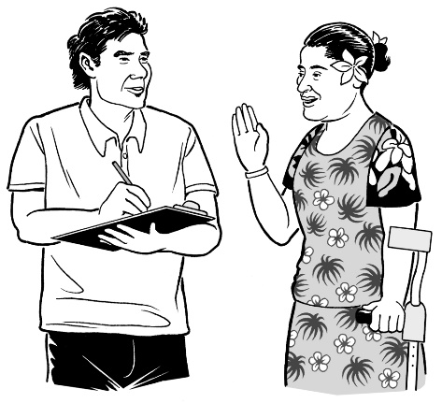
You can speak up about:
- the things you know from your own life

- the things you think need to change for all of New Zealand.

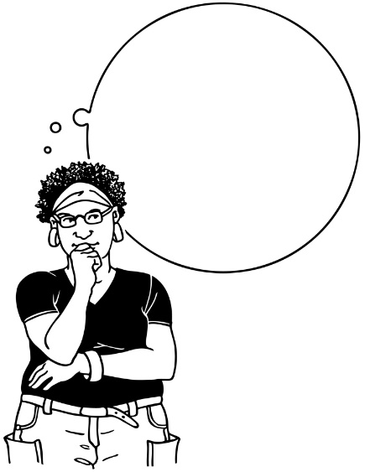
We want to hear:
- what you think

- how you think we can make things better.

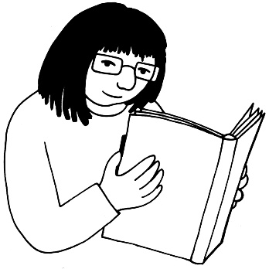
If you have other documents you want us to read you can also attach them to your form.

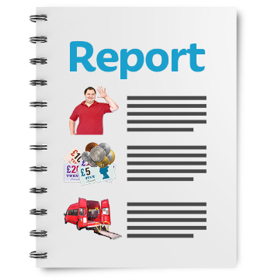
We will read every form that is sent to us.

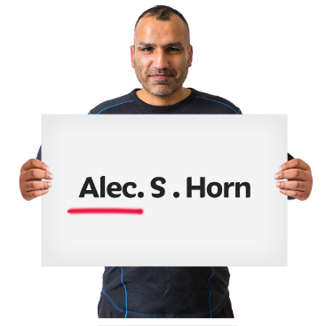
We will also write a report about what everyone has said.

We will not put your name in the report.
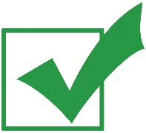
Only the people doing this work will see your name.

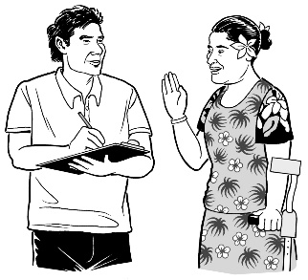
We may tell your story in the report.

If we tell your story we will try to make sure no one will know it is your story.

If you want parts of your story to be kept private you can tell us.
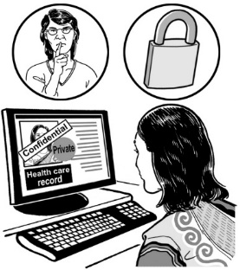

You can find out more about what we will do with your information on this website:

https://www.mentalhealth.inquiry.govt.nz/consultation-document/legal-information-about-your-submission/
Thank you for having a say.

Your voice is important.
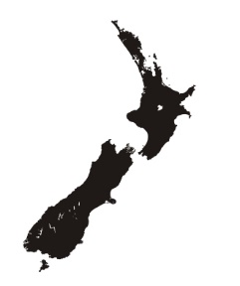
It will help us to make things better in New Zealand.

How to fill out the form

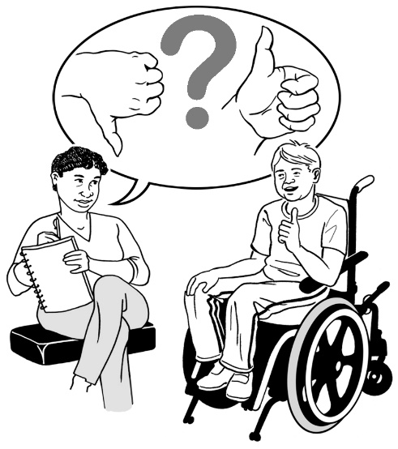
You can answer:

- all of the questions

or

- some of the questions.

It is up to you.
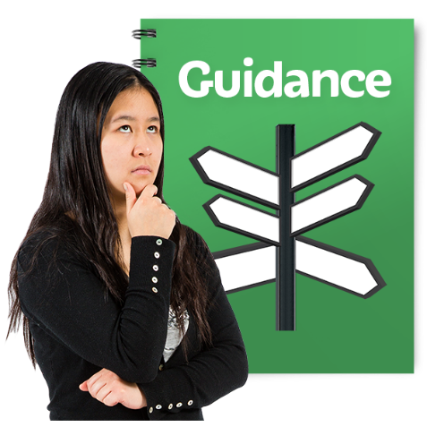

You can also tell us if there is something else we should have asked about.

You can answer the questions:

- online here:
https://www.mentalhealth.inquiry.govt.nz/consultation-document/
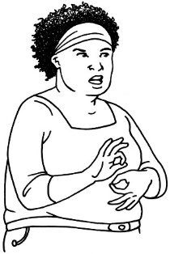
or

- in New Zealand Sign Language here:
https://www.mentalhealth.inquiry.govt.nz/consultation-document/have-your-say-new-zealand-sign-language/
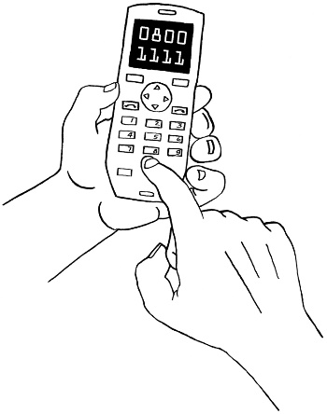
or

- over the phone.

If you want to do this call:

0800 644 678

This number is free to call from all over New Zealand.
You can also write your answers on this form and:

- email it to us at this email address:

mentalhealth@inquiry.govt.nz

or

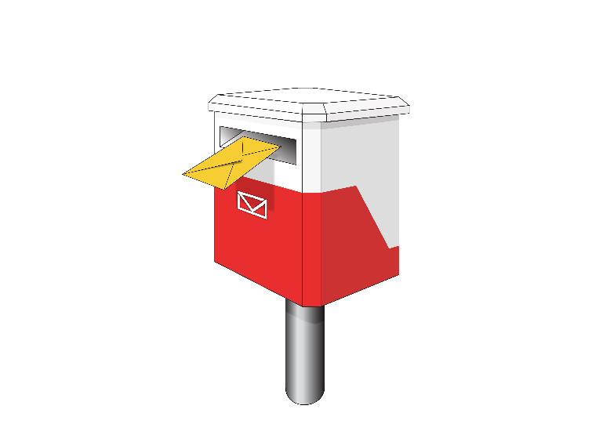
- post it to us at this address:

Mental Health and Addiction Inquiry
PO Box 27396
Marion Square
Wellington 6141

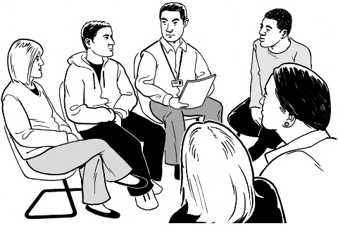
You can also come to a public meeting.

The group of people who are doing this work will be going to different places around New Zealand.

If you want to find out where the public meetings will be go to this website:

https://www.mentalhealth.inquiry.govt.nz/contact-us/opportunities-to-connect/#Regional-visits

The questions
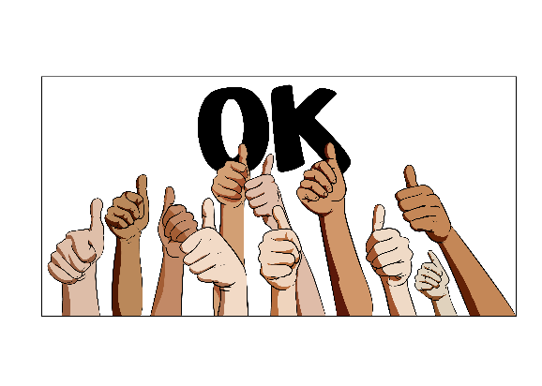

- What is working well in New Zealand around:

- Mental Health?

- Addiction?

__________________________________________________

__________________________________________________

__________________________________________________

__________________________________________________

__________________________________________________

__________________________________________________

__________________________________________________

__________________________________________________

__________________________________________________

__________________________________________________
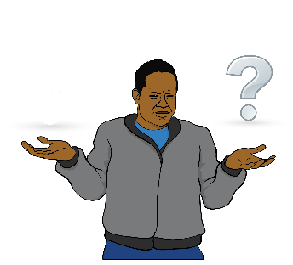
Why do you think these things are working well?

__________________________________________________

__________________________________________________

__________________________________________________

__________________________________________________
__________________________________________________

__________________________________________________

__________________________________________________

__________________________________________________

__________________________________________________

__________________________________________________

__________________________________________________

__________________________________________________

__________________________________________________

__________________________________________________

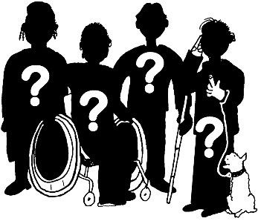
Who do you think these things are helping?

__________________________________________________

__________________________________________________

__________________________________________________

__________________________________________________

__________________________________________________

__________________________________________________

__________________________________________________

__________________________________________________

__________________________________________________
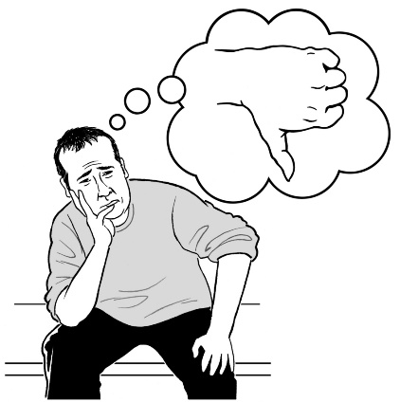
- What is not working well in New Zealand at the moment around:

- Mental Health?

- Addiction?

__________________________________________________

__________________________________________________

__________________________________________________

__________________________________________________

__________________________________________________

__________________________________________________

__________________________________________________

Who is not getting help?

__________________________________________________

__________________________________________________

__________________________________________________

__________________________________________________

__________________________________________________

__________________________________________________

__________________________________________________

__________________________________________________

__________________________________________________
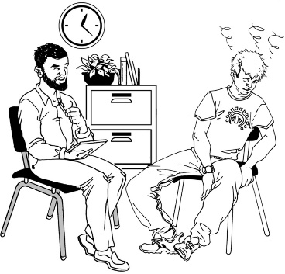
What are the problems with Mental Health or Addiction services?

__________________________________________________

__________________________________________________

__________________________________________________

__________________________________________________

__________________________________________________

__________________________________________________

__________________________________________________

__________________________________________________

__________________________________________________
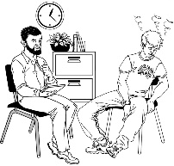
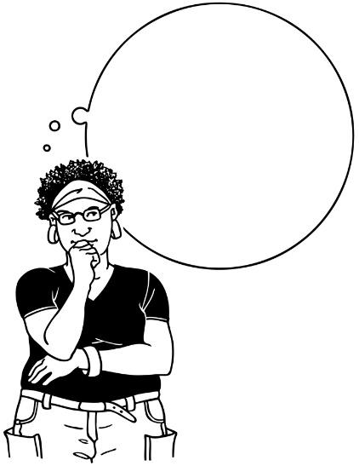
Thinking about Mental Health and Addiction services:
- What things are not happening now that you think should be happening?

__________________________________________________

__________________________________________________

__________________________________________________

__________________________________________________

__________________________________________________

__________________________________________________

__________________________________________________

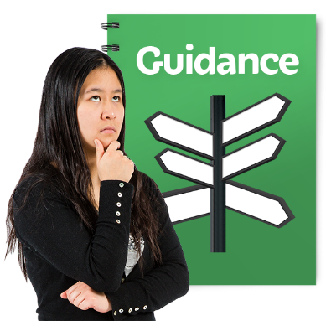
- What can we do to make things better in New Zealand around:

- Mental Health?

- Addiction?

__________________________________________________

__________________________________________________

__________________________________________________

__________________________________________________

__________________________________________________

__________________________________________________

__________________________________________________

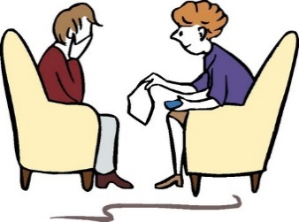
How can we give people better support?

__________________________________________________

__________________________________________________

__________________________________________________

__________________________________________________

__________________________________________________

__________________________________________________

__________________________________________________

__________________________________________________

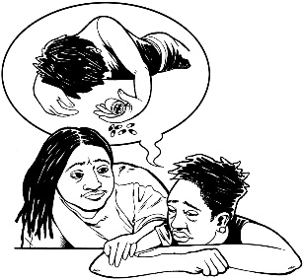
How can we stop people from feeling so bad that they do not want to live anymore?

__________________________________________________

__________________________________________________

__________________________________________________

__________________________________________________

__________________________________________________

__________________________________________________

__________________________________________________

__________________________________________________

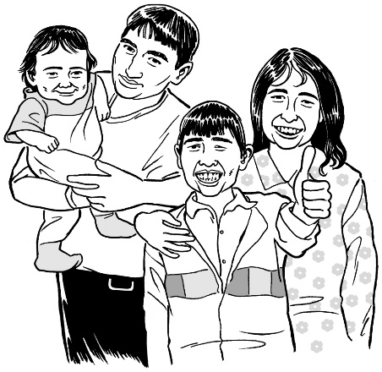
How can we stop people from having problems with:

- Mental Health?

- Addiction?

__________________________________________________

__________________________________________________

__________________________________________________

__________________________________________________

__________________________________________________

__________________________________________________

__________________________________________________
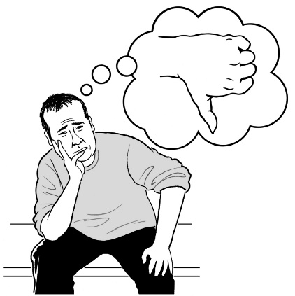
- Thinking about:

- Mental Health in New Zealand

- Addiction in New Zealand.
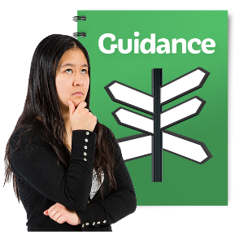
What things about New Zealand make these problems worse?

__________________________________________________

__________________________________________________

__________________________________________________

__________________________________________________

__________________________________________________

__________________________________________________
If you could change these things how would you change them?

__________________________________________________

__________________________________________________

__________________________________________________

__________________________________________________

__________________________________________________

__________________________________________________

__________________________________________________

__________________________________________________

__________________________________________________
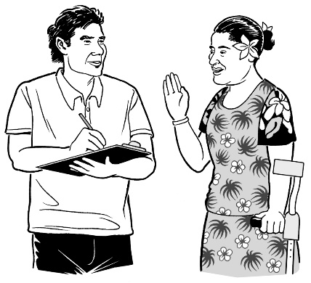
- Is there anything else you want to tell us about:
- Mental Health in New Zealand?

- Addiction in New Zealand?

__________________________________________________

__________________________________________________

__________________________________________________

__________________________________________________

__________________________________________________

__________________________________________________

__________________________________________________
__________________________________________________

__________________________________________________

__________________________________________________

__________________________________________________

__________________________________________________

__________________________________________________

__________________________________________________

__________________________________________________

__________________________________________________

__________________________________________________
Some questions about you
?
?
?
We have a few more questions.

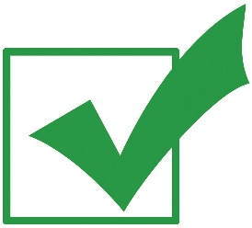
Please tick the answers that are right for you.
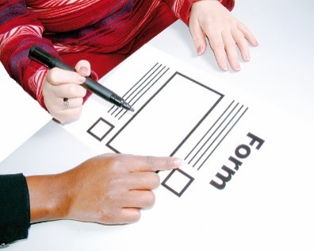

Who filled out this form?

          - Me – these are my thoughts

          - An organisation – this is what an organisation thinks.

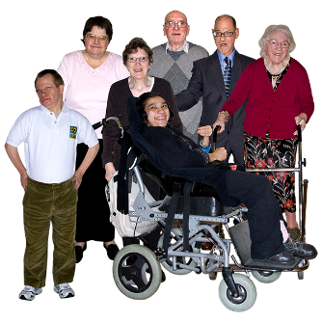
If it is an organisation please tell us the name of it here:

__________________________________________________

__________________________________________________

Can you please tell us a bit about you?
Please tick all the answers that are right for you.

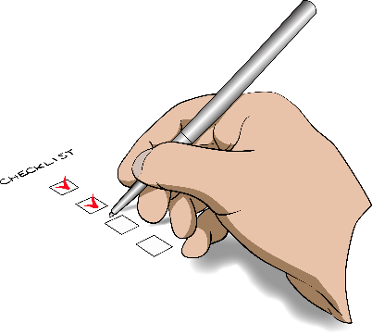
You can choose more than 1.

There are more choices on the next 2 pages.

I am:

- a person who has had mental health or addiction problems

- a friend of someone who has had mental health or addiction problems

- from a family / whānau that has had to deal with mental health or addiction problems

- a support worker

- someone who works for a service provider

Please tell us what kind of service you provide here:

__________________________________________________

__________________________________________________

- an advocate – someone who speaks up for people with mental health or addiction problems
- from an organisation that does not work for the Government

- a person who works for government

- a member of the public

- a student or someone who does research

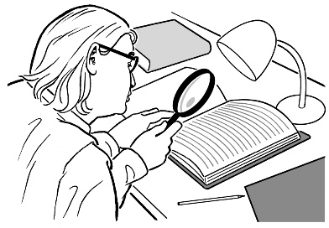
Research means:

- looking to find an answer to a question you have

- trying to find out how to do things better.
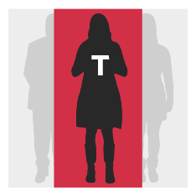
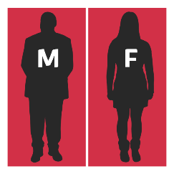
The next question is about your gender.

Please tick the answer that is right for you.

I am:

- female

- male

- other

Please tick this box if you do not want to say the gender you identify with.

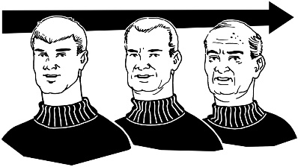
The next question is about your age.

Please tick the answer that is right for you.

There are more choices on the next page.

I am:

- under 16 years of age

- 16 – 24 years old

- 25 – 44 years old

- 45 – 64 years old

- 65 – 84 years old

- More than 85 years old

Please tick this box if you do not want to say how old you are.

This question is only for people who have used mental health or addiction services.
Please tick all the answers that are right for you.

You can choose more than 1.

There are more choices on the next 2 pages.

I am:

- Pākehā

- Māori

- Pacific peoples
- a child

- a young person

- an older person

- a person with a disability

- LGBTIQA+

This means:
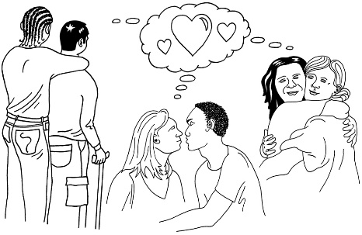
  - Lesbian
  - Gay
  - Bisexual
  - Transgender
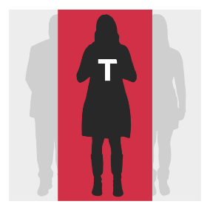
  - Intersex
  - Queer
  - Asexual

- someone who moved to New Zealand from another country

- someone who lives on a farm or out in the country

- someone who used to be in the armed forces

- a person in prison

- a person who has been convicted of a crime but is not serving their sentence in prison

- from another group:

__________________________________________________
This question is only for people who are filling out this form for an organisation.
Please tick all the answers that are right for you.

You can choose more than 1.

There are more choices on the next 2 pages.

Our organisation works with:

- Pākehā

- Māori

- Pacific peoples
- children

- young people

- older people

- people with disabilities

- LGBTIQA+

This means:
  - Lesbian
  - Gay
  - Bisexual
  - Transgender
  - Intersex
  - Queer
  - Asexual

- people who moved to New Zealand from another country

- people who live on farms or out in the country

- people who used to be in the armed forces

- people in prison

- people who have been convicted of crimes but are not serving their sentence in prison

- another group:

__________________________________________________
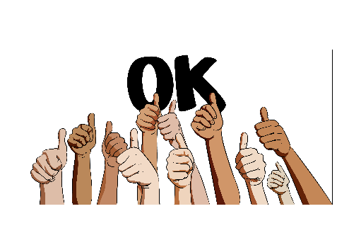
Keeping some of your form private

This question is for everyone.

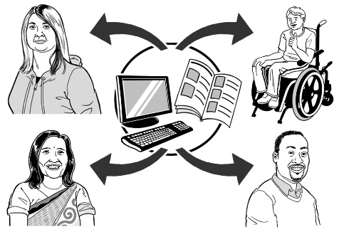
If you do not say you want to keep your form private your answers may be shared with the public.

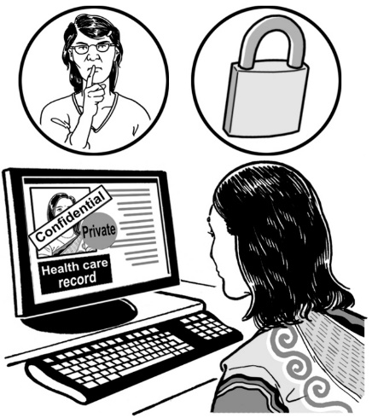
If you want to keep some of your form private you need to:

- highlight the parts you want to keep private

- tick 1 of the 3 boxes on the next page.

Tick the box that is right for you.

I do not want the parts I have highlighted to be used in the report at all.

You can use the highlighted parts in your report but I do not want anyone reading it to know I wrote them.

I do not want anyone working on this work to know that I wrote these answers.

To find more information about keeping your form private go to this website:

https://www.mentalhealth.inquiry.govt.nz/consultation-document/legal-information-about-your-submission/

How to find out more

You can get in touch with us on:
- our website
https://www.mentalhealth.inquiry.govt.nz/

- our free phone number:

0800 644 678

- email:

mentalhealth@inquiry.govt.nz

- Twitter:
https://twitter.com/MHInquiryNZ

- Facebook:
https://www.facebook.com/MentalHealthInquiryNZ/

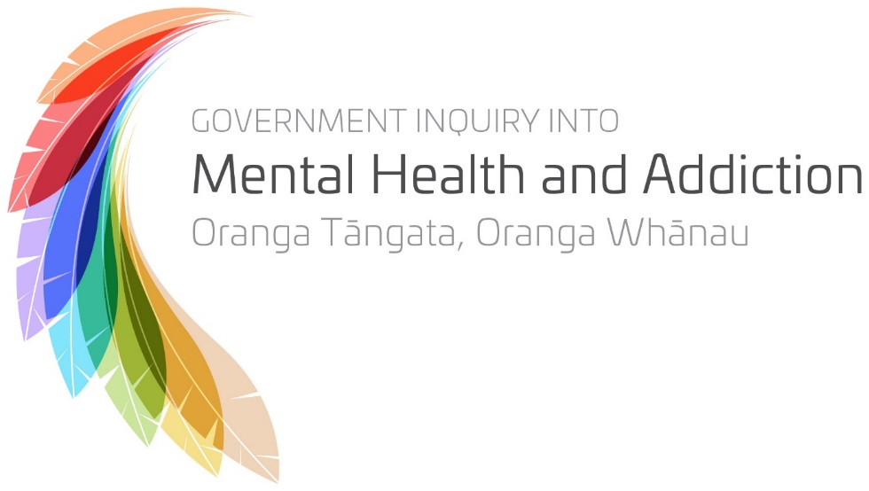

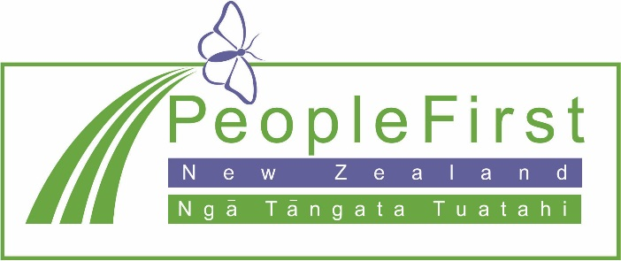

This information has been translated into Easy Read
by People First New Zealand Inc. Ngā Tāngata Tuatahi

